

Policy Number: | CU22 | Originator: | Stacey Clements
Issue Number: | 8 | Authoriser: | Claire Imber
Issue Date: | 01/09/2025 | Service Type: | Education
Next Review Due: | 01/09/2026 | Policy Location: | Policy File

Contents
1. Aims 2
2. Statutory requirements 2
3. Policy development 3
4. Definition 3
5. Curriculum 3
6. Delivery of RSE 4
7. Roles and responsibilities 4
8. Parents’ right to withdraw 5
9. Training 6
10. Monitoring arrangements 6
Appendix 1: Curriculum map 7
Appendix 2: By the end of primary school pupils should know 13
Appendix 2: By the end of secondary school pupils should know 16
Appendix 3: Parent form: withdrawal from sex education within RSE 20

1. Aims
The aims of relationships and sex education (RSE) at our school are to:
- Provide a framework in which sensitive discussions can take place
- Prepare pupils for puberty, and give them an understanding of sexual development and the importance of health and hygiene
- Help pupils develop feelings of self-respect, confidence and empathy
- Create a positive culture around issues of sexuality, gender identity and relationships
- Teach pupils the correct vocabulary to describe themselves and their bodies
- Support students to make safe choices and safeguard themselves against risk by recognising unhealthy relationships, youth produced sexual images (YPSI), sexual harassment and sexual violence and understanding how to report these effectively.
- Teaching will be personalised in the approach taken to meeting student’s needs and learning styles

2. Statutory requirements
With our KS2 pupils we must provide relationships education to all pupils as per section 34 of the Children and Social work act 2017.
However, we are not required to provide sex education but we do need to teach the elements of sex education contained in the science curriculum.
In teaching RSE, we must have regard to guidance issued by the secretary of state as outlined in section 403 of the Education Act 1996.
We follow the statutory requirements set out in Relationships Education, Relationships and Sex Education (RSE) and Health Education from Department of Education, 2019 and Keeping Children Safe in Education 2025. We are working towards the RSE statutory updates 2025 due to be in place by September 2026.
At The Greater Horseshoe School we teach RSE as set out in this policy.
With our secondary aged and post-16 pupils we provide RSE to all pupils as per the Children and Social work act 2017.
In teaching RSE, we must have regard to to guidance issued by the secretary of state as outlined in section 403 of the Education Act 1996.

3. Policy development
This policy has been developed in consultation with staff, pupils and parents. The consultation and policy development process involved the following steps:
- Review – a member of staff or working group pulled together all relevant information including relevant national and local guidance

- Staff consultation – all school staff were given the opportunity to look at the policy and make recommendations

- Parent/stakeholder consultation – parents and any interested parties were invited to attend a meeting about the policy

- Pupil consultation – we investigated what exactly pupils want from their RSE

- Ratification – once amendments were made, the policy was shared with governors and ratified

4. Definition
RSE is about the emotional, social and cultural development of pupils, and involves learning about relationships, sexual health, sexuality, healthy lifestyles, diversity and personal identity.
RSE involves a combination of sharing information, and exploring issues and values.
RSE is not about the promotion of sexual activity.

5. Curriculum
Our curriculum is set out as per Appendix 1 but we may need to adapt it as and when necessary.
We have developed the curriculum in consultation with parents, pupils and staff, taking into account the age, needs and feelings of pupils. If pupils ask questions outside the scope of this policy, teachers will respond in an appropriate manner so they are fully informed and don’t seek answers online.
Primary sex education will focus on:
- Preparing all students regardless of gender for the changes that adolescence brings
- How a baby is conceived and born
For more information about our curriculum, see our curriculum map in Appendix 1.

6. Delivery of RSE
KS2
RSE is taught within the personal, social, health and economic (PSHE) education curriculum. Biological aspects of RSE are taught within the science curriculum, and other aspects are included in religious education (RE). The RSE scheme used is the Brook SEND scheme, supplemented with additional resources from Cre8tive Resources.
Pupils may also receive stand-alone sex education sessions delivered by a trained health professional.
Relationships education focuses on teaching the fundamental building blocks and characteristics of positive relationships including:
- Families and people who care for me
- Caring friendships
- Respectful relationships
- Online relationships
- Being safe
- Consent
- Self-worth
- Attraction to others
- Marriage including same sex
For more information about our RSE curriculum, see Appendices 1 and 2.

KS3
RSE focuses on giving young people the information they need to help them develop healthy, nurturing relationships of all kinds including:
- Families
- Respectful relationships, including friendships
- Consent
- Gender and sexual identity
- Online and media, including pornography, sexting and youth produced sexual images
- Sexual harassment and assault
- Being safe
- Intimate and sexual relationships, including sexual health and contraception
For more information about our RSE curriculum, see Appendices 1 and 2.

KS4
RSE develops on previous learning and supports students to make safe choices as they move towards adulthood.
- Respectful relationships, including friendships
- Gender and sexual identity
- Consent
- Online and media, including pornography, sexting and youth produced sexual images
- Sexual harassment and assault
- Being safe
- Intimate and sexual relationships, including sexual health and contraception
- Relationships and sex expectations
- Abortion and the law

KS5
- Respectful relationships and recognising abuse
- Consent
- Gender and sexual identity
- Online and media, including pornography, sexting and youth produced sexual images
- Sexual harassment and assault
- Being safe and sexual health
- Intimate and sexual relationships, including sexual health and contraception
- Abortion and the law
- Fertility, pregnancy

These areas of learning are taught within the context of family life taking care to ensure that there is no stigmatisation of children based on their home circumstances (families can include single parent families, LGBT parents, families headed by grandparents, adoptive parents, foster parents/carers amongst other structures) along with reflecting sensitively that some children may have a different structure of support around them (for example: looked after children or young carers).

7. Roles and responsibilities
7.1 The governing board
The governing board has delegated the approval of this policy to Tracy McEwen
7.2 The headteacher
The headteacher is responsible for ensuring that RSE is taught consistently across the school, and for managing requests to withdraw pupils from components of RSE (see section 8).
7.3 Staff
Staff are responsible for:
- Delivering RSE in a sensitive way considering person-centred, trauma-informed, neuro-affirming approaches
- Modelling positive attitudes to RSE
- Monitoring progress
- Responding to the needs of individual pupils
- Responding appropriately to pupils whose parents wish them to be withdrawn from the components of RSE
Staff do not have the right to opt out of teaching RSE. Staff who have concerns about teaching RSE are encouraged to discuss this with the Head of Faculty for Life Skills.
Stacey Clements will oversee the day to day planning and delivery of the RSE curriculum under the direction of the Senior Leadership Team (SLT). Other teaching staff will be supported to deliver the RSE curriculum as per the school plans and schedule, including teachers, tutors and learning support assistants.
7.4 Pupils
Pupils are expected to engage fully in RSE and, when discussing issues related to RSE, treat others with respect and sensitivity.

8. Parents’ right to withdraw
Parents do not have the right to withdraw their children from sex and relationships education in Key Stages 3, 4 and 5.
Parents have the right to withdraw their children from the relationship components of sex education within RSE within Key Stage 2.
Requests for withdrawal should be put in writing using the form found in Appendix 3 of this policy and addressed to the headteacher.
Alternative work will be given to pupils who are withdrawn from sex education.

8.1 Parents Right to View Resources
Following an announcement from Secretary of State for Education on March 2023, parents have the right to view the resources that will be used to teach their children in school. This is to ensure that students can continue these supportive conversations at home.

Parents will be invited to view resources via presentations or parent portal. If parents are unable to view them via these platforms, they have the option to request these in printed form, although would be encouraged to view via the aforementioned platforms to ensure that they are viewed in context. This enables parents to best support students at home with their learning.

9. Training
Staff are trained on the delivery of RSE as part of their induction and it is included in our continuing professional development calendar.
The headteacher will also invite visitors from outside the school, such as school nurses or sexual health professionals, to provide support and training to staff teaching RSE.

10. Monitoring arrangements
- The delivery of RSE is monitored by Peta Hewitt (Headteacher) through:
- Learning walks, work quality assurance and pupil progress checking.
- Pupils’ development in RSE is monitored by class teachers as part of our internal assessment systems.
- This policy will be reviewed by Head teacher at every review, the policy will be approved by Claire Imber

Appendix 1: Curriculum map
PSHE education curriculum map

Relationships and Sex Education is embedded within the PSHE Curriculum as outlined below for Key Stages 2-5.
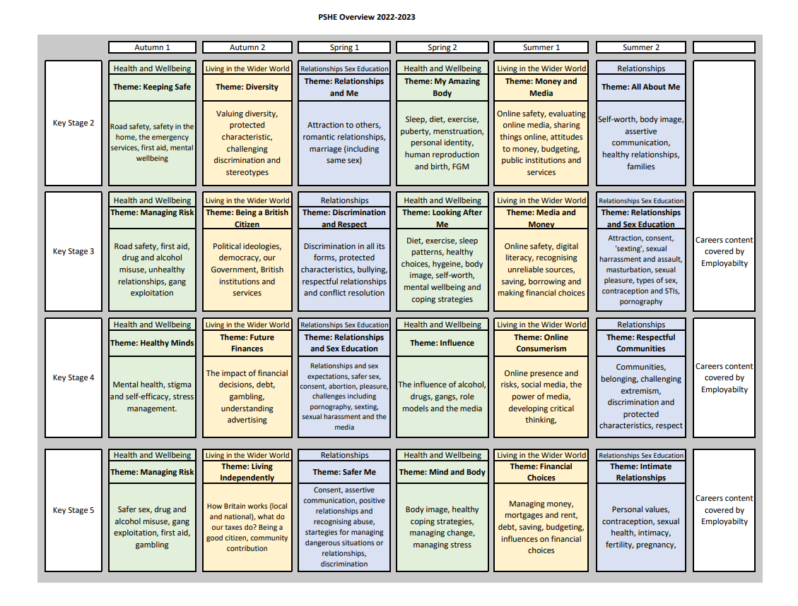

Appendix 2: By the end of primary school pupils should know
Topic | Pupils should know
Families and people who care about me | - That families are important for children growing up because they can give love, security and stability  - The characteristics of healthy family life, commitment to each other, including in times of difficulty, protection and care for children and other family members, the importance of spending time together and sharing each other’s lives  - That others’ families, either in school or in the wider world, sometimes look different from their family, but that they should respect those differences and know that other children’s families are also characterised by love and care  - That stable, caring relationships, which may be of different types, are at the heart of happy families, and are important for children’s security as they grow up  - That marriage represents a formal and legally recognised commitment of two people to each other which is intended to be lifelong  - How to recognise if family relationships are making them feel unhappy or unsafe, and how to seek help or advice from others if needed
Caring friendships | - How important friendships are in making us feel happy and secure, and how people choose and make friends  - The characteristics of friendships, including mutual respect, truthfulness, trustworthiness, loyalty, kindness, generosity, trust, sharing interests and experiences and support with problems and difficulties  - That healthy friendships are positive and welcoming towards others, and do not make others feel lonely or excluded  - That most friendships have ups and downs, and that these can often be worked through so that the friendship is repaired or even strengthened, and that resorting to violence is never right  - How to recognise who to trust and who not to trust, how to judge when a friendship is making them feel unhappy or uncomfortable, managing conflict, how to manage these situations and how to seek help or advice from others, if needed
Respectful relationships | - The importance of respecting others, even when they are very different from them (for example, physically, in character, personality or backgrounds), or make different choices or have different preferences or beliefs  - Practical steps they can take in a range of different contexts to improve or support respectful relationships  - The conventions of courtesy and manners  - The importance of self-respect and how this links to their own happiness  - That in school and in wider society they can expect to be treated with respect by others, and that in turn they should show due respect to others, including those in positions of authority  - About different types of bullying (including cyberbullying), the impact of bullying, responsibilities of bystanders (primarily reporting bullying to an adult) and how to get help  - What a stereotype is, and how stereotypes can be unfair, negative or destructive  - The importance of permission-seeking and giving in relationships with friends, peers and adults
Online relationships | - That people sometimes behave differently online, including by pretending to be someone they are not  - That the same principles apply to online relationships as to face-to face relationships, including the importance of respect for others online including when we are anonymous  - The rules and principles for keeping safe online, how to recognise risks, harmful content and contact, and how to report them  - How to critically consider their online friendships and sources of information including awareness of the risks associated with people they have never met  - How information and data is shared and used online
Being safe | - What sorts of boundaries are appropriate in friendships with peers and others (including in a digital context)  - About the concept of privacy and the implications of it for both children and adults; including that it is not always right to keep secrets if they relate to being safe  - That each person’s body belongs to them, and the differences between appropriate and inappropriate or unsafe physical, and other, contact  - How to respond safely and appropriately to adults they may encounter (in all contexts, including online) whom they do not know  - How to recognise and report feelings of being unsafe or feeling bad about any adult  - How to ask for advice or help for themselves or others, and to keep trying until they are heard  - How to report concerns or abuse, and the vocabulary and confidence needed to do so  - Understanding what female genital mutilation (FGM) is and how to report concerns safely  - Where to get advice e.g. family, school and/or other sources

KS3/4

Appendix 2: By the end of secondary school pupils should know
Topic | Pupils should know
Families | - That there are different types of committed, stable relationships  - How these relationships might contribute to human happiness and their importance for bringing up children  - What marriage is, including their legal status e.g. that marriage carries legal rights and protections not available to couples who are cohabiting or who have married, for example, in an unregistered religious ceremony  - Why marriage is an important relationship choice for many couples and why it must be freely entered into  - The characteristics and legal status of other types of long-term relationships  - The roles and responsibilities of parents with respect to raising of children, including the characteristics of successful parenting  - How to: determine whether other children, adults or sources of information are trustworthy: judge when a family, friend, intimate or other relationship is unsafe (and to recognise this in others’ relationships); and, how to seek help or advice, including reporting concerns about others, if needed
Respectful relationships, including friendships | - The characteristics of positive and healthy friendships (in all contexts, including online) including: trust, respect, honesty, kindness, generosity, boundaries, privacy, consent and the management of conflict, reconciliation and ending relationships. This includes different (non-sexual) types of relationship  - Practical steps they can take in a range of different contexts to improve or support respectful relationships  - How stereotypes, in particular stereotypes based on sex, gender identity, race, religion, sexual orientation or disability, can cause damage (e.g. how they might normalise non-consensual behaviour or encourage prejudice)  - That in school and in wider society they can expect to be treated with respect by others, and that in turn they should show due respect to others, including people in positions of authority and due tolerance of other people’s beliefs  - About different types of bullying (including cyberbullying), the impact of bullying, responsibilities of bystanders to report bullying and how and where to get help  - That some types of behaviour within relationships are criminal, including violent behaviour and coercive control  - What constitutes sexual harassment, sexual assault and rape and why these are always unacceptable  - The legal rights and responsibilities regarding equality (particularly with reference to the protected characteristics as defined in the Equality Act 2010) and that everyone is unique and equal
Online and media | - Their rights, responsibilities and opportunities online, including that the same expectations of behaviour apply in all contexts, including online  - About online risks, including that any material someone provides to another has the potential to be shared online and the difficulty of removing potentially compromising material placed online  - Not to provide material to others that they would not want shared further and not to share personal material which is sent to them  - What to do and where to get support to report material or manage issues online  - The impact of viewing harmful content  - That specifically sexually explicit material e.g. pornography presents a distorted picture of sexual behaviours, can damage the way people see themselves in relation to others and negatively affect how they behave towards sexual partners  - Youth Produced Sexual Imagery, consent and the law.  - How information and data is generated, collected, shared and used online
Being safe | - The concepts of, and laws relating to, sexual consent, sexual exploitation, abuse, grooming, coercion, harassment, assault, rape, domestic abuse including coercive control, forced marriage, honour-based violence and FGM, and how these can affect current and future relationships  - How people can actively communicate and recognise consent from others, including sexual consent, and how and when consent can be withdrawn (in all contexts, including online)  - How to report concerns safely within school and to outside organisations.
Gender and sexual identity | - There are a range of sexualities and gender identities.  - Some people will be different to us and that is ok.  - That sexual activity can be enjoyed regardless of gender and sexual identity.
Intimate and sexual relationships, including sexual health | - How to recognise the characteristics and positive aspects of healthy one-to-one intimate relationships, which include mutual respect, consent, loyalty, trust, shared interests and outlook, sex and friendship  - That all aspects of health can be affected by choices they make in sex and relationships, positively or negatively, e.g. physical, emotional, mental, sexual and reproductive health and wellbeing  - That sex should feel pleasurable and should be with someone they trust and respect.  - The facts about reproductive health, including fertility and the potential impact of lifestyle on fertility for men and women  - That there are a range of strategies for identifying and managing sexual pressure, including understanding peer pressure, resisting pressure and not pressurising others  - That they have a choice to delay sex or to enjoy intimacy without sex  - The facts about the full range of contraceptive choices, efficacy and options available  - The facts around pregnancy including miscarriage  - That there are choices in relation to pregnancy (with medically and legally accurate, impartial information on all options, including keeping the baby, adoption, abortion and where to get further help)  - How the different sexually transmitted infections (STIs) are transmitted, how risk can be reduced through safer sex (including through condom use) and the importance of and facts about testing  - About the prevalence of some STIs, the impact they can have on those who contract them and key facts about treatment  - How the use of alcohol and drugs can lead to lower inhibitions and risky sexual behaviour  - How to get further advice, including how and where to access confidential sexual and reproductive health advice and treatment including through the C-Card Scheme and Devon Sexual Health

Appendix 3: Parent form: withdrawal from sex education within RSE

To be completed by parents
Name of child |  | Class
Name of parent |  | Date
Reason for withdrawing from sex education within relationships and sex education
Any other information you would like the school to consider
Parent signature

To be completed by the school
Agreed actions from discussion with parents | Include notes from discussions with parents and agreed actions taken.  Eg: Joe Bloggs will be taking part in all relationships lessons and during the sex education lessons, he will be working independently on a project in the Year 5 classroom

