

Policy Number: | CU06 | Originator: | Stacey Clements
Issue Number: | 9 | Authoriser: | Peta Hewitt
Issue Date: | 01/03/26 | Service Type: | Education
Next Review Due: | 01/03/27 | Policy Location: | Policy File

1. Aim of the policy
This document aims to outline the Greater Horseshoe School’s Policy for the Curriculum in line with the schools’ vision:
The Greater Horseshoe School has a simple vision; to provide “the best education for every child”. We recognise that this is different for every child that we work with but this vision frames everything that we do. We want GHS to provide the best environment both physically and emotionally to ensure that our children get the best outcomes.

2. The theory behind the curriculum approach
A note on terminology throughout this document:

Neurodiversity describes how people experience and interact with the world around them in many different ways; there is no one "right" way of thinking, learning, and behaving, and differences are not viewed as deficits. Neurodiversity refers to the diversity of all people including neurotypical and neurodivergent people. 'Neurotypical' people think, perceive, behave, and process information in ways considered standard or typical in the general population. Neurodivergent people - such as autistic people, and those with neurological or developmental conditions such as ADHD or learning disabilities - are people whose brain functions and behaviours can diverge from those considered typical.

Within The Greater Horseshoe School there are a wide range of children and young people who need a curriculum offer and approach to teaching and learning that was not available in their previous education settings. The term ‘staff’ in this booklet is used to encompass the full range of adults in our schools and colleges, including senior leaders, teachers, teaching assistants, support staff and clinicians.

2.1 OFG Trauma Informed Practice 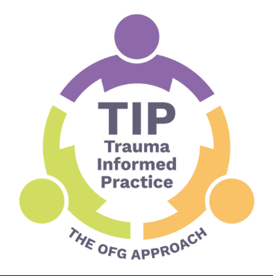 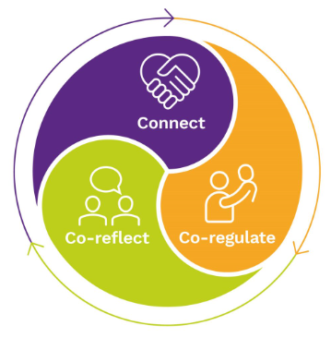
OFG Trauma Informed Practice supports staff in understanding the impact of trauma on a student’s early experiences, the subsequent internal world they developed and how this relates to the survival skills (or behaviours) they have developed. This approach helps us to meet and respond thoughtfully to the underlying need, rather than respond to behaviour. The 3C’s Model of Connect, Co-regulate, and Co-reflect is a comprehensive approach, aimed at promoting consistency of practice. It is based on the current evidence base, exploring the importance of relationships that young people require in trauma recovery:
Connect helps young people feel ‘seen’ and kept in mind,
Co-regulate develops and supports a sense of safety,
Co-reflect is to support with therapeutic boundaries which help traumatised children learn safe and effective ways of living their lives.

2.2 OFG Autism / Neurodivergent Strategy 

OFG Autism / Neurodivergent Strategy describes our approach to the provision of education and clinical services to autistic individuals in an environment which is conducive to their strengths and needs. The strategy recognises that despite underlying shared traits, autistic individuals are vastly different from one another and takes inspiration from positive, optimistic person-centred approaches that emphasise the importance of genuine engagement, empathic relationships, increasing an individual’s experiences of positive emotions and meaningful achievements. The foundation of the strategy is based upon the principles of Ask, Accept and Develop:
Ask is the top priority because we recognise the importance of consulting to the autistic / neurodivergent individual above anything else; we listen to their perspectives and our staff will treat the autistic student as a unique individual with their own likes, dislikes, wants and needs.
Accept within the Autism / Neurodivergent Strategy means that our staff will understand autism / neurodivergence in a way that is intellectual, practical, and cultural. They understand the strengths and needs associated with diagnosis, whilst also appreciating each student’s own personal strengths and needs. Our focus is to create environments, communication systems and activities which meet the needs of the autistic student and enable them to thrive and experience positive emotions.
Develop: We will teach and scaffold the development of new skills, abilities, and strategies for autistic/ neurodivergent students in our schools. The teaching and development of skills will be derived from a student’s personal goals, informed by their family’s views, and used to drive improvements in their quality of life and wellbeing. The focus is to enable and empower each individual student to increase their independence and flourish.

2.3 Attachment Theory
Attachment theory is a widely accepted framework for understanding children’s social and emotional development. Our Autism / Neurodivergent and Trauma Informed strategies start from the important relationship between student and staff and its place in helping students develop a sense of independent ‘self’. Our students need consistent and predictable adults, who enable students to predict how they and others will behave and interact. Without this, their ability to understand and regulate their behaviour, relationships and communications is impaired.
Our staff provide opportunities to interact, have conversations and model behaviours and positive relationships. This helps students form social and psychological foundations for learning. Activities are age and stage appropriate; routines are predictable; and there are many opportunities to repeat and embed each new skill. Within attachment theory, a positive outcome later on in life is dependent on attachments made in the early years and therefore it is important to ensure that our students have the opportunity and are able to develop positive relationships with adults.
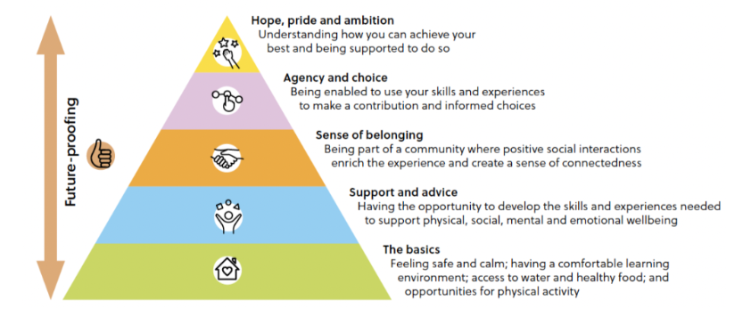
2.4 The Six Principles of Nurture
The Six Principles of Nurture - nurtureuk
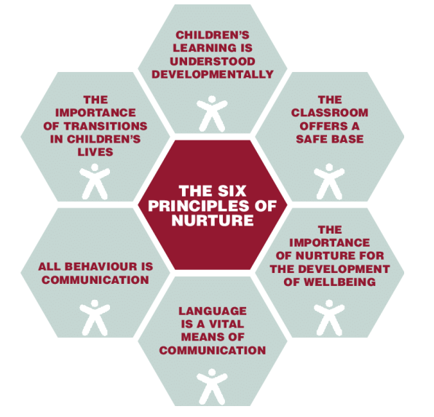
1. Children's learning is understood developmentally.
Our staff are trained respond to students not in terms of arbitrary expectations about ‘attainment levels' but in terms of their holistic developmental progress. This may be informed by formal clinical assessments, as well as by the school or college’s own assessment systems (Evidence for Learning). The response to the student is ‘as they are', underpinned by a non-judgemental and accepting attitude. We do this by a ‘bottom-up’ approach based upon the neuro-sequential model (Dr Bruce Perry).
2. The classroom, school / college offers a safe base.
The organisation of environments is designed to reduce anxiety. Physical spaces offer a balance of educational and sensory experiences aimed at supporting the development of student understanding of their own emotional regulation needs, their relationships with each other and with
the staff. The day is organised around structured periods of time with predictable routines. Attention is paid to details, with staff being reliable and consistent in their approach to the students. OFG schools, colleges and classrooms make the important link between emotional containment and cognitive learning, by enhancing predictability.
3. The important development of well-being and self-esteem.
Nurture involves listening and responding, with an emphasis on staff engaging with students in reciprocal shared activities (play / meals / reading / talking about events and feelings). Patterned and repetitive activities that help to calm the brainstem are known to be helpful (Dr Bruce Perry). Students (and staff!) respond to being valued and thought of as individuals, so we notice and praise achievements; nothing is hurried – the student dictates the pace.
4. Language is understood as a vital means of communication.
Language is more than a skill to be learned, it is the way of putting feelings into words. Our students often ‘act' their feelings as they lack the vocabulary to ‘name' them. Informal opportunities for talking and sharing, like welcoming the student into the classroom or having a meal together, are as important as formal lessons teaching language. Words are used to label and express feelings, and opportunities created for conversations or imaginative play to understand the feelings of others.
5. Behaviour is communication.
Our staff respond with curiosity about student behaviour we find difficult or challenging. ‘Given what I know about this student, what is this behaviour telling me?' Understanding a student is communicating through behaviour helps staff to respond in a calm and non-punitive way. All staff are trained in Crisis Prevention Institute (CPI), part of the Restraint Reduction Network, to gain knowledge and skills in this area. If the student can sense that their feelings are understood this can help to diffuse difficult situations. Staff make the link between the external / internal worlds of the student, supported through the use of PACE (Dan Hughes).
6. Transitions are significant in the lives of children.
Our staff help students make the transition from home or care to school at the start and end of every day. Daily, there are numerous transitions between activities and classes and between different adults. Changes in routine can be difficult for our students, needing careful preparation and support. Visual supports and structure are key tools used within trusting relationships with key adults who understand child development and the impact of neurodivergence.

2.5 The Neuro-Sequential Model
The psychiatrist, Dr Bruce Perry, developed the neuro-sequential model: children’s brains organise from bottom to top, with the brainstem ‘survival brain’ developing earliest, and the cortical areas ‘thinking brain’ much later. Some of our students get ‘stuck’ in the brainstem, swinging between survival modes of fight / flight / freeze / collapse. A helpful way to move students from these high-anxiety states to their calmer ‘thinking brain’ is repetitive rhythmic activity. Creating a therapeutic web of relationships around the student together with regular brainstem calming activities (which are based on relationships with a trusted adult, developmentally relevant, repetitive, rewarding, rhythmic and respectful) can, over time, help a student’s brain and body learn that they are safe.
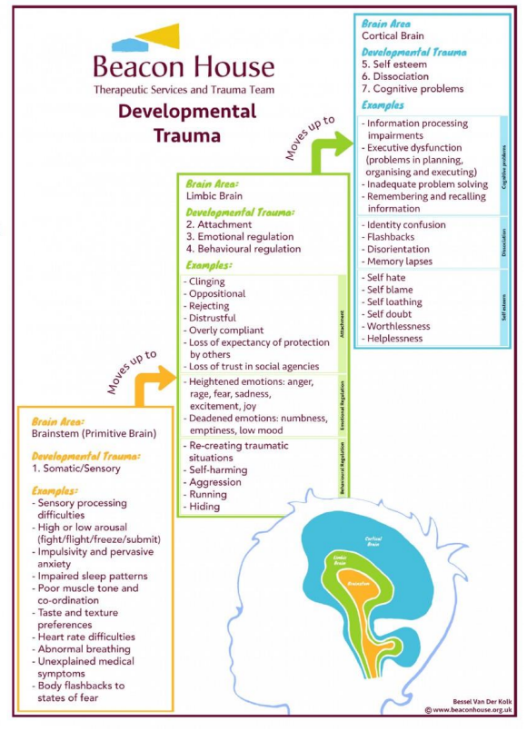
2.6 Polyvagal Theory
The work of neuropsychologist Stephen Porges has helped us to understand what happens to us all when we perceive danger. His polyvagal theory suggests a hierarchy of three levels: Freeze, Fight/Flight, Social Engagement.
When we do not feel safe, the body prepares itself to respond to danger. If the danger seems very great, the nervous system is activated in such a way that we have a very high tolerance for pain, and often become very still. In this ‘freeze’ state, which is the state of greatest stress, students sometimes appear to ‘zone out’, show confusing behaviours such as laughing inappropriately as though they cannot stop, or even appear to fall asleep. Sometimes this is called “dissociation”.
When we perceive threat that is not at the highest level the body prepares itself for defence. Sometimes we call this “fight or flight”. Some of our students can escalate into this state very quickly. It may look as though there was no trigger, or that the apparent trigger was very small. Many of our students are vulnerable to experiencing ‘fight, fright or flight’ reactions in everyday situations which would not normally make individuals feel afraid. This reaction is not conscious, is completely involuntary and out of their control. For students to be ready to learn, however, they need to be in the calm, open and engaged state described in the graph. Only in this state can they engage with and reflect on what has happened together.
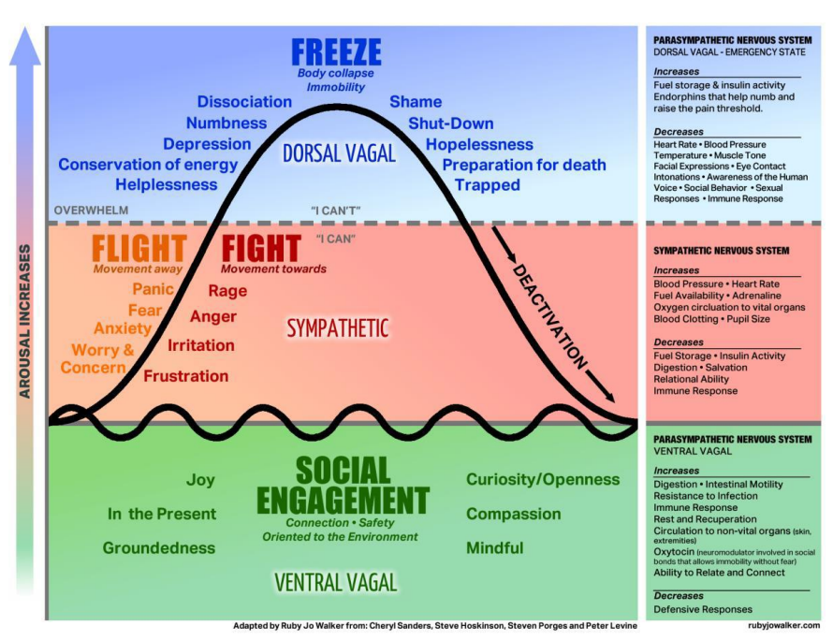
Some of our staff have been additionally trained in the ‘Thrive’ model, which emphasises that a safe relationship is necessary before a student is ready to engage in learning and aims to help staff develop empathy and compassion, including through understanding the potential origins of a student’s behaviour. Thrive includes a focus on understanding how the establishment of the body’s stress-regulation system lays the foundation for our social and emotional development throughout life, affecting our capacity to relate, love, learn and manage stress in healthy ways, particularly through play.

2.7 PACE
PACE: an approach developed by Dr Dan Hughes, an American psychologist is at the heart of our Trauma Informed Practice and our Autism / Neurodivergent Strategy. PACE stands for Playfulness, Acceptance, Curiosity and Empathy. These principles help to promote the experience of safety in staff interactions with students. Students need to feel that staff have connected with the emotional part of their brain before they can engage the thoughtful, articulate, problem-solving areas.
Playfulness The purpose of playfulness is to enjoy being together in an unconditional way. This gives the message that the relationship is stronger than things that go wrong. Staff using a playful and lighthearted tone, as if they were telling a story, shows interest and curiosity. Playfulness reduces the shame a student might feel when something has gone wrong; difficult messages or serious conversations can be easier to have if the tone is light. It does not mean staff do not take the emotions or the incident seriously.
Acceptance Unconditional acceptance is core to a student’s sense of safety because it shows that staff have connected with their feelings without judgement, and without seeking to reassure their feelings away. Accepting the student’s feelings and emotions does not mean accepting unsafe behaviour and it does not mean agreeing with the child’s viewpoint, but for true acceptance to take place, it is important that the student also knows staff can see them beyond their behaviour. With a student who may dysregulate daily, this can be hard to do. Therefore, staff use reflective practice with colleagues in which they can reflect on the student beyond their behaviour as well as expressing their own feelings about events.
Curiosity It is important for staff to be curious about the students’ thoughts, feelings, wishes and intentions: they may still be learning that other people can think about them in this way or that they can be held in mind by an adult without judgement and accusation at all. Staff showing the student that they are interested in what is going on for them and willing to do something about it is a very powerful experience. Staff try to be curious in a quiet, accepting tone that conveys a simple desire to understand the student: this is not the same as agreeing with their perception of the event, but shows interest in understanding it and accepting the feelings that were involved.
Empathy When staff show empathy, they show the student that their feelings are important, and that they are alongside them in their difficulty. They are showing that they can cope with the hard times with them and are trying hard to understand how it feels. Empathy is the capacity to understand or feel what another person is experiencing from within their frame of reference – the capacity to place oneself in another’s position – the ability to understand and share the feelings of another. This is different to sympathy (feelings of pity or sorrow for someone else’s misfortune). Brene Brown describes empathy as fuelling connection, whereas sympathy drives disconnection. Empathy involves perspective taking, is non-judgmental, recognises emotion in others and communicates that feeling. It is empathic connection that will make a student feel better, rather than the staff member trying to resolve or make it better. Fundamental to empathy is the acceptance and recognition of the student as a unique individual – staff should open awareness to their experience and listen to what it means to them.
3. Policy
3.1 School Context
The Greater Horseshoe School is registered by the DfE to provide education for students between the ages of 8-18 across three separate sites; School, Chipley Mill and Musers. Our curriculum covers Key Stages 2,3, 4 and 5. This policy sets out the curriculum through all key stages.
Students will be based at one or more sites as appropriate to meet the needs of the student where they access a broad and balanced curriculum in an approach suiting and meeting students’ needs and appropriate to the environment. Our safe and secure base at our school in Heathfield offers a well-stocked library, Independent Life Skills base, a science laboratory, food technology classroom, multi-use games area (MUGA), outdoor gym and specialist play equipment to support sensory needs.
Chipley Mill has enabled the school to extend its’ curriculum provision into a specialist vocational centre offering the fields of Animal Care, Horticulture, Design Technology and Forest School together with an appreciation of our natural environment and sustainability. Chipley Mill Farm also provides enormous therapeutic benefits for many of our students and may suit students who have had adverse experiences within previous educational settings and would benefit from a less traditional setting.
Musers is our Media, Music and Technology hub located a short walk from the main school site. Students may spend some or much of their time there, where the site is suited to media and technology but forms the best learning environment for some individuals who thrive in this environment, therefore used by all subjects as a learning space.
Students will follow the school intent planning set out across all three sites, led by curriculum Heads of Faculties. Our overall intent is as per the schools’ vision is to provide “the best education for every child”. We recognise that this is different for every child that we work with but this vision frames everything that we do. We want GHS to provide the best environment both physically and emotionally to ensure that our children get the best outcomes for them.
3.2. Curriculum Statement the Greater Horseshoe School
At the Greater Horseshoe School, we recognise that every individual is unique. We aim to provide a bespoke education programme for our students which encourages and supports their development holistically which builds confidence and self-esteem in readiness to access the curriculum offer. Our curriculum enables our students to value and enjoy education, whilst striving to maximise their potential.
In line with the 1988 Education Reform Act, the Greater Horseshoe School strives to promote the spiritual, moral, cultural, social, emotional and physical development of all students in school and society. Through themed days and weeks a selected theme is threaded throughout the curriculum to promote and develop this entitlement. Developing student’s spiritual, moral, social and cultural (SMSC) awareness is at the heart of our curriculum and learning outside the classroom is a key area in our work to encourage personal development. Teachers’ planning will seek opportunities for students to work together and learn in the surrounding community. Consequently, we accompany students on a wide range of out of school activities including; trampolining, rock climbing, go-karting, dog-walking, bowling, sea-life centre visit, zoo visits, caving, cinema, horse-riding, ice-skating, pottery and visits to local places of interest. We are constantly working to develop a network of suitable employers to increase our provision of work experience placements. Most recently, our students have benefitted from work placements in; Office Administration, Painting and Decorating, Animal Care and with The National Trust.
Our overarching aim at the Greater Horseshoe School is to provide the highest quality education where inclusion, enrichment and progression enables personal achievement for all students in preparation for the responsibilities, experiences and opportunities of adult life (with appropriate levels of support). The promotion of British Values and Cultural Capital is achieved through school assemblies and school information. Personal, Social, Health, Economic (PSHE) Education at the school ensures the students have access to statutory and more content and experiences, learning fundamental life skills and enhancing the school’s culture and ethos. PSHE includes Relationships and Sex Education (RSE) to assure students with the knowledge and skills for healthy and safe lives. School life promotes democracy, law and order, individual liberty and freedom of speech, together with mutual tolerance and respect for race, culture, gender and religious belief through our curriculum and its’ delivery. All teachers are responsible to teach and role model these British Values and Cultural Capital, as we aim to promote cohesion and prepare our students for life as good citizens in a modern, multi-cultural United Kingdom.
We wholeheartedly believe that our curriculum actively promotes personalised learning and holistically prepares students to experience success and achievement every day, whilst developing the life skills required for a safe, healthy and aspirational independent future.

The enhanced curriculum at the Greater Horseshoe School is principally designed to re-engage our students with learning thus starting to provide them with opportunities to prepare for successful adult life. Typically, our students have had their learning significantly disrupted and they often struggle to remain focused on learning within the confines of a school environment. Early life traumas may create additional barriers to success in education. We offer a broad and balanced curriculum ensuring students access appropriate statutory curricula. In addition, we provide relevant information to foster safer choices and start to develop the vocational skills that will enable our students to live as independently as possible and succeed in the world of work.
Particular emphasis is placed on the school’s curriculum, communication and self-directed behaviour strategies for lifelong learning. Wherever possible we aim to provide access and inclusion opportunities to mainstream education and other community-based leisure and social activities geared towards the promotion of independent living.
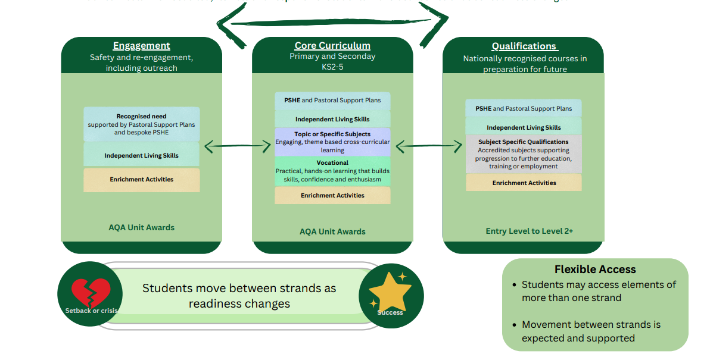
With three distinct strands, Engagement, Core and Qualifications, our curriculum is needs-led, flexible and responsive. The curriculum is planned to encourage independence and group learning opportunities via a full range of experiences and activities that are appropriate to each students’ needs, abilities, age and interest. Upon arrival at the school, students are placed onto one of three strands based on referral guidance, discussions with the young person and their family or carers and are assessed through baselining as the most appropriate strand to meet the needs of students. The strand reviews are ongoing and are adjusted to students’ safety, engagement in planned activities, progress in attainment, Thrive assessment and their emotional readiness for the next strands.
We understand that progress is rarely linear for young people with complex needs and history of trauma. Therefore movement between strands is expected and supported. Students may access elements of more than one strand, as appropriate and may skip strands. For example, if a student is accessing the Qualifications Strand and experiences a significant set back or crisis such as a period of significant mental ill health or a family breakdown it may be appropriate for them to move to the Engagement Strand to support the emotional needs of the student until they are ready to resume their studies in the Qualifications Strand. They may not move to the Core Strand in this situation.
3.3. Engagement Strand
Teaching within the Engagement Strand includes:
- High quality, warm relationships and interactions during planned and student-initiated play and activities
- The skilled use of modelling: showing, explaining, demonstrating
- Encouraging students to explore ideas through encouragement and skilled use of questioning and recall
- Providing narratives in a way a student can understand, for what they are doing
- Facilitating and setting personalised challenges
- Making informed use of resources for sensory and hands-on learning
- With staff knowing each student as an individual well – their strengths and interests as well as their learning dispositions and needs
- With that information used to inform their interactions at that point in time as well as planning next steps and monitoring progress
- Within a well-planned physical environment and structured day that makes use of repeated routines
The highly experienced, committed and specialist staff team at The Greater Horseshoe School will initially work with each student to identify individual interests and strengths, as well as the particular challenges to be overcome in order to access learning; therefore, our approach is patient, flexible and based on unique individual needs, which are formulated into personalised learning. We provide a safe, secure and stimulating learning environment wherein our staff actively seek opportunities to engage and work with students. We uphold a culture of high expectation, which supports every member of the school community to grow, develop and maximise their achievement. We aim to establish and maintain positive, dynamic and purposeful working relationships across the school.
PSHE underpins our practice across all strands. Bespoke PSHE teaching will be delivered discreetly to support students’ recognised needs ensuring personal safety, healthy relationships, safety within their local communities and strategies to support their wellbeing. These will be recorded on Pastoral Support Plans.
Extensive work to support Independent Living Skills through the promotion of real life opportunities for applied literacy and numeracy, practical sciences, cooking, real life communication interactions and supporting independence through developing strategies to manage the challenges they experience in their everyday lives. Executive function and problem-solving skills develop through experiences and practice, from first learning to pay attention (supported by relationships with responsive adults). The development of executive functioning, thinking and problem-solving can be seen as integral to the foundation of Independent Living Skills as well as academic learning.
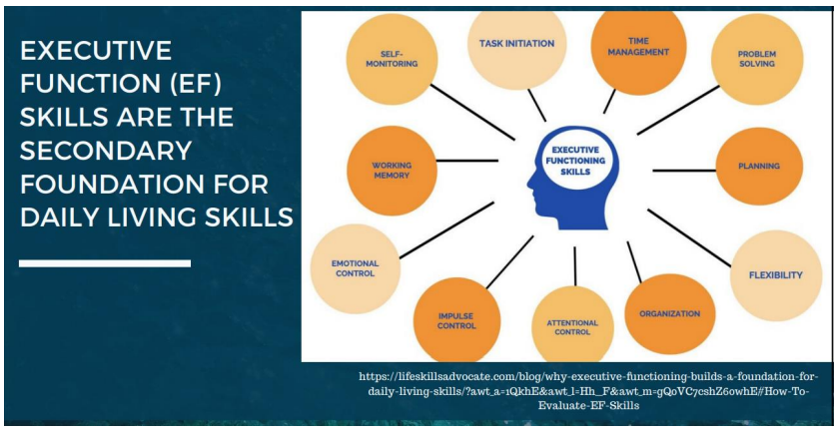
Enrichment activities can build on the skills developed in PSHE and Independent Living Skills or may be linked to student interest, meeting sensory needs or supporting other areas of the EHCP. These may be offered on or offsite as appropriate to the young person. All students up to the end of Year 11 are offered at least two hours of movement and exercise to support their physical and mental development and wellbeing. This may include but is not limited to forest school, horse care, climbing, cycling, walking, playing in parks or group activities at break and lunch times.
If it is appropriate, students on the Engagement Strand are able to access other areas of the curriculum such as specific subject teaching, topic, vocational or entry level qualifications. These can be included as part of the enrichment activities if they appeal to student interests or alternatively can be gradually added to support a young person to transition to another strand in line with the young person’s readiness to access this.
All learners on the Engagement Strand will be supported to work towards AQA Unt Awards. The AQA Unit Award Scheme offers a unique way to record student achievement through focusing on a ‘can-do’ approach to boost student confidence, engagement and motivation. Students are rewarded with a certificate each time they successfully complete a unit of learning which can build up to a portfolio of certificates to evidence their skills, knowledge and experience and which is issued when they leave school alongside all other certificates, award and external qualifications they have achieved. The scheme covers all topics from traditional school curriculum subjects plus life skills, outdoor activities, arts and crafts and work-related learning. Students of all ages and abilities can take part and teachers can write their own units for tailored bespoke learning, as appropriate.
3.4. Core Strand
In addition to the offer to all students, accessing the Engagement Strand, learners accessing the Core Strand will access the following areas:
- The full PSHE curriculum across the three areas of Health and Wellbeing, Living in the Wider World and Relationships and Health Education for children in Key Stage 2 or Relationships Health and Sex Education for learners in Keys Stages 3, 4 and 5. The curriculum is designed around the PSHE Association and meets the statutory requirements. Relationships and Sex Education content is delivered to young people to according to their physiological age and adapted and delivered to suit the individual needs of the learner. Further information can be found in the Relationships Health and Sex Education Policy (CU22).

- Independent Living Skills following the OFG Incredible Futures Careers Curriculum and accruing AQA Unit Awards evidencing the skills, knowledge and experience they develop throughout. Further information can be found in the Careers Policy (CU18).

- Topic is cross-curricular, thematic learning that involves establishing patterns of information between different academic subjects and offers a creative way of developing knowledge, understanding and practical skills through a study of interconnected topics. This results in students having fun, being more actively involved and developing learning skills more effectively, as each one is connected to and reinforced by the other. It is key that we allow our students to connect their learning to real-world experience wherever possible – so they see the purpose to the learning. The students are likely to be more confident and better motivated as a result, especially where we build in and make links to their own particular areas of interest.

New concepts are delivered through a theme each half term or term and enable the student to acquire and demonstrate new skills. Built into the curriculum is community-based learning (as previously discussed), generally increasing as students progress through the key-stages, and time to address personal and social skills such as independence and interacting with others. English (including language and communication skills), Maths / Problem-Solving and ICT have a great emphasis placed upon them. They are core strands of knowledge and skill used throughout learning and development, as well as the wider curriculum. Nothing is taken for granted and everything is explained, supported by role modelling, demonstration and the use of communication supports and visuals as appropriate.

Emphasis is placed on the experience gained through completing activities as opposed to the “end product” and it focuses upon developing student’s communication, engagement and experiences. Curriculum access will be designed to ensure that the experience of students at key stage 2, for example, will be very different to the experiences of key stage 4 students, regardless of the level that they may be working at. Although sessions are planned and delivered in a variety of ways (group and individually) all teaching should be adapted to the needs of the individual. The intention for the curriculum is to maximise engagement in the learning process and to provide opportunities to develop their strengths, taking students on to adult life with a love for learning and with skills to take them beyond the world of education.

The themes are mapped out in Long Term Planning, allowing for a spiral curriculum approach that allows for both progress and repetition as students move up through a school’s key-stages, bearing in mind a student may join a school at any point in their education journey. Mapping out priority learning targets helps staff have a clear vision, with the connections between curriculum areas within the theme being natural rather than forced. Reflection is also an important component within the planning process – staff need to be flexible in their planning enabling them to respond to the success of the implementation of the plan as well as individual student needs and interests as each term and school year progresses. Senior leaders and Heads of Faculty can support teacher and tutor planning and reflection through learning walks and curriculum planning scrutiny. All students will have the opportunity to acquire AQA Unit Awards to demonstrate the skills and experience they acquire.

- All students have the opportunity to experience a range of vocational topics across all three sites to support them to gain a greater understanding of what each area involves, to acquire skills, knowledge and experience to support their development and to inform their future choices. The only barrier to a student accessing a specific site would be concerns around theirs or others’ safety. Safeguarding will always be our highest priority. All students will have the opportunity to access a carousel of learning with one topic per half-term. The topics are: horticulture, animal care, cooking, design technology, music and media and drama. These are planned by subject specialists to promote fun, high quality education that engages the young person. All students will have the opportunity to acquire AQA Unit Awards to demonstrate the skills and experience they acquire.

- Enrichment activities can build on the skills developed in PSHE, Independent Living Skills, Topic or Vocational or may be linked to student interest, meeting sensory needs or supporting other areas of the EHCP. These may be offered on or offsite as appropriate to the young person. All students up to the end of Year 11 are offered at least two hours of movement and exercise to support their physical and mental development and wellbeing. This may include but is not limited to forest school, horse care, climbing, cycling, walking, playing in parks or group activities at break and lunch times.

3.5. Qualifications Strand
As students’ develop a range of strategies that they can employ to support their individual and complex needs they will increase their resilience, their trust in the staff that support them and their willingness to step outside of their comfort zone. With this, comes a readiness for students to access the Qualifications Strand.
In year 9, all students are supported to make their option choices by staff and parents or carers. This enables learners to focus on the areas of the curriculum that interest them the most and ensure that they continue to engage and build on the skills, knowledge and experience to support them towards independence.
At The Greater Horseshoe School, we offer Entry Level, Level 1 and Level 2 qualifications across City and Guilds, Pearson Edexcel, AQA, Arts Awards and Duke of Edinburgh Award Scheme. We are currently being accredited for OCR. All students at Key Stage 4 benefit from a broad and balanced curriculum suited to their interests, ambitions and specific needs. This includes English, Maths, Science (this can include an applied science such as horticulture or animal care), Independent Living Skills including Careers Education, Personal Social Health and Economic Education including Relationships Health and Sex Education, vocational subjects, computing and at least two hours of movement and exercise to support their physical and mental development and wellbeing. This may include but is not limited to forest school, horse care, climbing, cycling, walking, playing in parks or group activities at break and lunch times.
As with all other strands, student benefit from enrichment activities to support their continued development in addition to the core curriculum offer.
Students in post-16 continue to work towards a Level 2 qualification in English and Maths if they have not obtained this by the end of Key Stage 4. In addition, they benefit from PSHE including RHSE, Independent Living Skills and Careers Education. All other subjects are opted for by students to ensure that each young person is able to develop their skills, knowledge and experience to support their next steps towards further training, education or employment.

4. Assessment
When staff are clear about what students already know and can do, and what they need to learn next, then they can decide what to teach the students and how best to use their time with them to ensure that they learn the intended curriculum. Every interaction a staff member has with a student is an opportunity for teaching and learning.
4.1 Education Health Care Plans
All students have an Education, Health and Care Plan (EHCP) in place which details their needs and how they should be met under the four key areas of:
- Cognition and Learning
- Communication and Interaction
- Social, Emotional and Mental Health
- Sensory and/or Physical Needs
It is a legally binding document that outlines any special educational needs (SEN) a student has, and the provision the local authority must put in place to support the student to overcome these needs. An EHCP is for students whose needs are significant and complex and that are impacting on their educational progress significantly.
We therefore have a statutory duty to fulfil the requirements of each student’s EHCP, will contribute to the assessments to put one in place where this is not yet the case and it is required, and lead in its formal Annual Review. Each EHCP will be reviewed annually in line with when written – but anyone can call review meeting at any time outside of that schedule. The ‘Outcomes’ within the EHCP will need to inform the students personalised learning targets and the ‘Provision’ will inform how you meet their stated needs to help achieve those outcomes.
At The Greater Horseshoe School we use Evidence for Learning platform’s ‘Personalised Learning Goals’ (PLG) function to record every student’s EHCP Long Term Outcomes with short -term (Termly) smart targets set, baselined and assessed using a consistent format and assessment schema, with supporting evidence attached to confirm teacher judgements. This enables us to assure we supporting and enabling best progress for our students in line with our statutory obligations at an individual, cohort, whole school and whole group level. This data is then used to inform the statutory Annual review.
The Annual Review is the statutory process of looking at the needs, provision and outcomes specified in an EHCP and deciding whether these need to change. The placing Local Authority (LA) must complete the first review of the EHCP within 12 months of the EHCP being finalised. Subsequent reviews must be completed within 12 months of the previous review.
The following steps must take place in an Annual Review:
- The LA must consult with parents and with the school about the EHCP, and take account of Student and Parental views, wishes and feelings.
- An Annual Review meeting must take place to discuss the EHC plan – usually organised and held at school.
- Information must be gathered from student, parents and professionals about the EHCP, and then circulated two weeks before the meeting.
- After the meeting a report of what happened must be written and sent to everyone who went to the meeting or provided information to be discussed within two weeks of the meeting taking place.
- After the meeting the LA reviews the EHCP.
- The LA must notify the parents and school of its decision within four weeks of the meeting.
All of these steps – not just the meeting – must be followed in order for an Annual Review to be completed.
Students on all three strands of the curriculum will be assessed against termly smart targets from the EHCP targets . These will be assessed by all staff working with students in conjunction with the subject specific assessments. Enrichment Activities will be assessed according to PLGs and this will form the main basis of assessments for students on the Engagement Strand.
Assessments from Evidence for Learning will contribute to the Annual Review Report in order to accurately inform on progress. Our trained SENCOs will have a bank of additional assessments they can use to help inform student needs and progress made. Our Clinical team are also able to support with specialist assessments. However, staff will also be using assessment for and of learning as part of their daily practice.
4.2 Formative and summative assessment
High quality education is important for all. We see high quality education as inclusive with special educational needs identified quickly and supported effectively so that all students can progress well in their learning. Effective assessment is part of high-quality education and requires staff to understand child development and neurodiversity.
Students will be assessed in the school using assessment systems appropriate to the subject and course requirements, in line with schools’ Marking Policy (SU16). Assessment is ongoing, as formative and summative. School staff assess progress and report using the school’s systems as well as assessment frameworks adapted from the National Curriculum or in line with external qualification providers. Progress data is analysed and reported each term, sending reports home to parents and carers for the Autumn and Summer terms. Interventions and catch ups are informed from this information along with intended outcomes and progression pathways. Flightpaths use this information to track and report progress and aspiring destinations.
We need to be aware of the impact our teaching and interventions are having and whether these are positively impacting upon the learning and the quality of life of our students in the way they, their families and ourselves want. Schools and Colleges also have a statutory duty to report on student progress to all key stakeholders, including Annual Review of EHCPs, Annual Reporting to Parents, and Personal Education Plans (PEPs) for those student in the care system.
This supports our personalised approach to education and provision and can allow all stakeholders in a student’s learning and development (including education staff, clinical staff, parents and carers) to quickly and easily gather commentary, photo and video evidence, linked to the student’s individual learning goals. Observations can be annotated and tagged to reflect indicators and it supports any assessment / curriculum framework and any assessment model our schools and colleges use as well as evidencing and tracking progress against individual learning intentions and targets related to EHCP outcomes. Staff can amend and add to these goals over time to respond to a student’s ongoing needs and development.
5. Equality Impact Statement
All relevant persons are required to comply with this policy and must demonstrate sensitivity and competence in relation to all protected characteristics. If you, or any other groups, believe you are disadvantaged by this policy please contact the Regional Director for Acorn Education and Care. Outcomes First Group will then actively respond to the enquiry.

