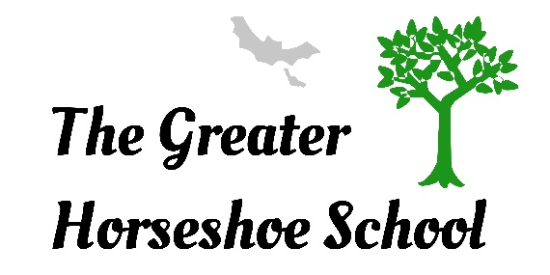

Policy Number: | SU02 | Originator: | Richard Hibbert
Issue Number: | 7 | Authoriser: | Pete Jenkins
Issue Date: | 30.09.26 | Service Type: | Education
Next Review Due: | 30.09.27 | Policy Location: | Policy File

1. Aim of the policy
This policy outlines the process for admissions to the School.

2. Background
The Greater Horseshoe School is registered with the Department of Education and Employment to support the educational needs of 8–18-year-olds who are experiencing social, emotional and behaviour and/or learning difficulties that may not be supported adequately in other settings.

3. Policy
3.1. Admissions criteria
The Admission criteria must be met before a student can be formally accepted for a place at the school. The following may apply:

- The student has specific needs associated with Education Health Care Plan.
- The student is aged 8-18 years.
- The student has moderate learning difficulties, sometimes with associated behaviours that may be considered challenging (this may include Autism, a variety of syndromes as well as those children affected by Social, Emotional and Mental Health).
- The student is in the care of Outcomes First Group, coming from out of the local area with a history of non-engagement in education.
- Funding must be agreed by the relevant authorities before a placement may commence.

3.2. Referral Pathway
Students are usually referred through their Local Education Authority. On occasion they may be referred by Social Services or their Health Authority.

It is not uncommon for parents, carers or interested parties to make the first contact for information regarding a place at the school. Staff must signpost parents/carers or interested parties to the correct information/staff member if they wish their child to be considered for a place at the school.

3.3. Visits to the School
Interested parties may arrange a visit to the school and meet with appropriate staff (e.g. Senior leadership team, SENCo, Family Support worker, Clinical Team) to discuss their child’s needs. This will often take place on an Open Evening or similar group event. The visit will include the opportunity to look around one of the school sites and assess the suitability for their child. If all agree that The Greater Horseshoe School would be the correct placement for the child, an arrangement may be made for a suitable time for appropriate staff to conduct an observation and assessment.

3.4. Observation and assessment
If the child requires a residential placement, then senior residential team members will also conduct an observation and assessment of the prospective student.

A member of Senior Leadership will request all relevant information relating to the child. This will include the Education, Health and Care Plan (EHCP) and reports from Educational Psychologists. Any information from the child’s previous school, behaviour support team or previous risk assessments and documentation could also be useful if available.

3.5. The Greater Horseshoe School Admissions Policy
The resulting report and supporting documentation is then considered and if assessing staff agree that attendance at the Greater Horseshoe School will meet the student’s individual needs, the offer of a placement is made in writing to the referring authority. A copy of a draft contract will also be sent to the child’s Local Education Authority. Local Authority staff are always welcome to visit the school prior to any referral being made, during the referral process or at any time during the student’s placement.

3.6. Placement Process
Once the placement is confirmed, then an appropriate member of staff (e.g. SENCo, Assistant SENCo, SLT, FSW) will make contact with parent(s)/carer(s) to discuss the transition process and gather information relating to the young person’s routines, likes, dislikes, family circumstances and other relevant details. At this time an Initial Risk Assessment will commence and views about the placement exchanged.

It may also be appropriate for key staff members to begin to establish links with the student in their current educational and residential placement to support the transition process to The Greater Horseshoe School. Where it is deemed appropriate, the prospective student may visit the school to become familiar with the new environment.

4. Equality Impact Statement
All relevant persons are required to comply with this policy and must demonstrate sensitivity and competence in relation to diversity in race, faith, age, gender, disability and sexual orientation. If you, or any other groups, believe you are disadvantaged by this policy please contact the Regional Director for Acorn Education and Care. Outcomes First Group will then actively respond to the enquiry.

